**DATABASE PROJECT REPORT**

DEVELOPED BY UZAIR ALI 18K-1148

# :INTRODUCTION:

I developed multiplayer (FPS) game in unity which allows player to play with each other and kill each other by throwing projectile at each other online using PHOTON UNITY

# :MOTIVATION:

Game development generates the most revenue even more than the movies and as we all know the games PUBG OR CODM it is also a first person shooter game which took the whole world by storm. So that gave me the idea and I implemented the basic idea of how that game works.

# :SIGNIFICANCE:

Like other Database projects this projects is unique because among all other project there is only my project which implements database in games and showcase FPS game mechanics.

# :DESCRIPTION:

The idea for this project came form two popular games known as PUBG and CODM.

# :FEATURES:

This project features MAMP (equivalent to XAMP) through my game can store and retrieve player XP From the database. On each spawn the player is spawned with maximum health of 100, When hit by the projectile, the player’s health is decreased by 10. If a player scores 2 kills then he wins the game and the game saves the score to the database.

# :HARDWARE & SOFTWARE REQUIREMENTS:

To run this project the system should have at least 2GB of ram and INTEL HD 530 GPU or better in addition to this a better internet connection is required as this game is multiplayer only.

# :ERD & FRONT END SCREENS:

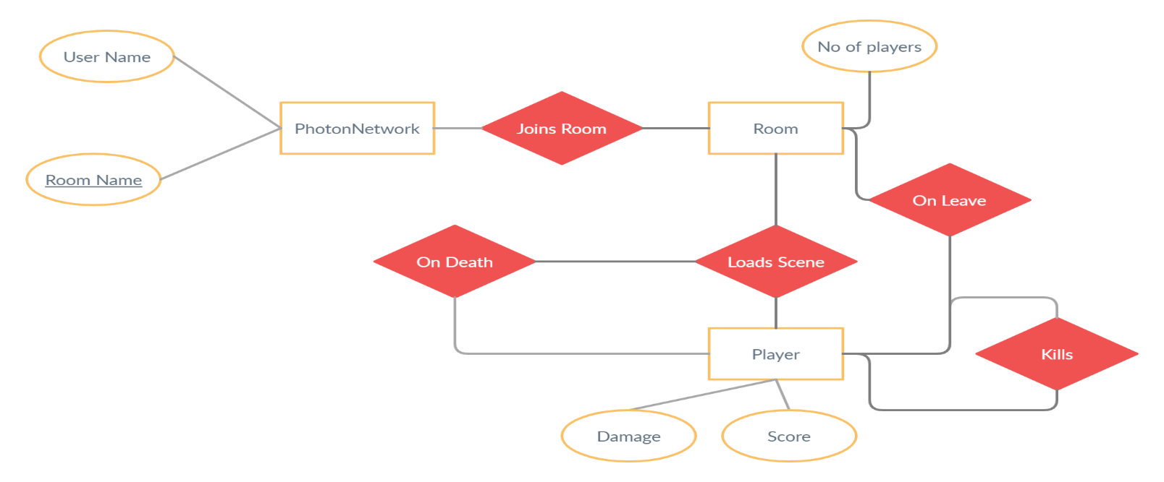

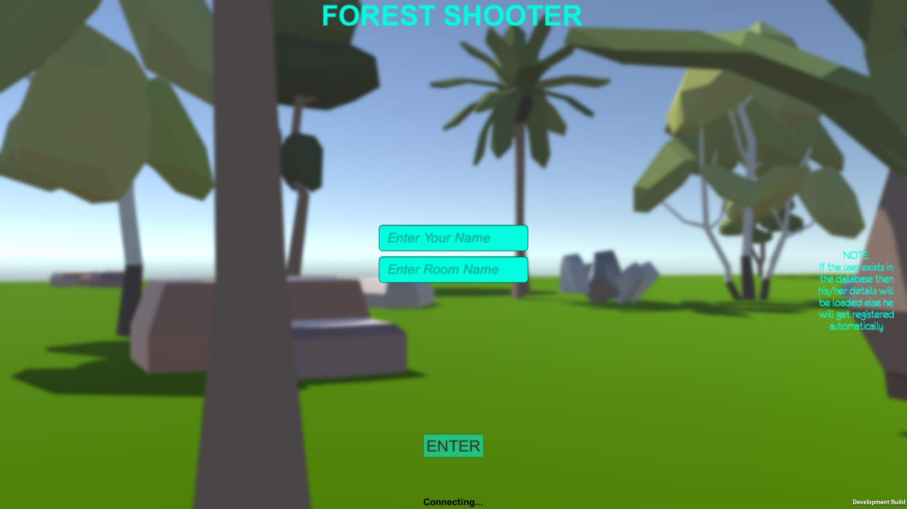

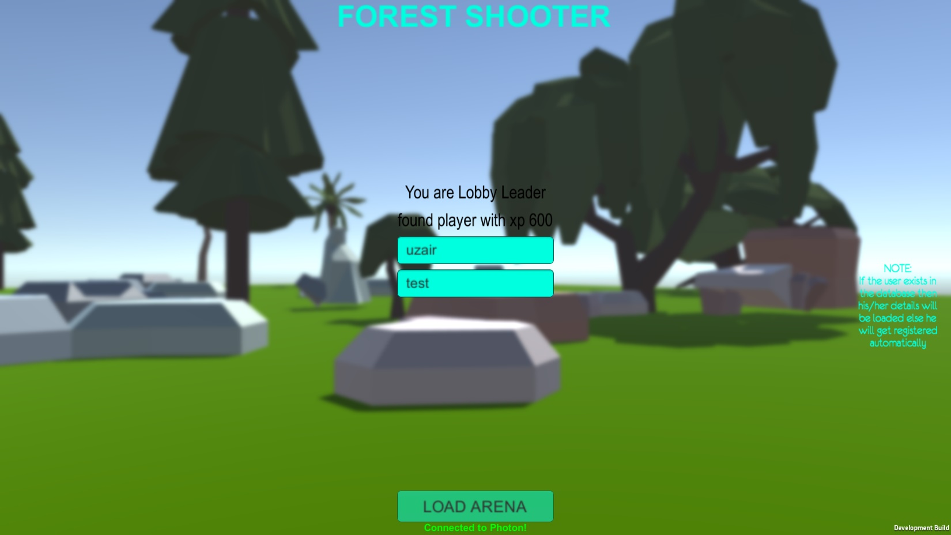

MAIN MENUES OF THE GAME WITH LOGIN

# :REFERANCES:

PHOTON ENGINE FOR ESTABLISHING MULTIPLAYER PLATFORM : <https://www.photonengine.com/pun>

UNITY ENGINE FOR GAME DEVELOPMENT : <https://unity.com/>

MAMP FOR DATABASE (MYSQLI, PHP) : <https://www.mamp.info/en/windows/>